**4.4 Applications of Midsegments HW**

*7/10 for completing the first page  
10/10 for back page as well*

1. 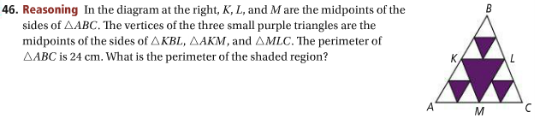 2.

/Users/Rasa/Desktop/Screen Shot 2016-11-08 at 7.35.48 PM.png

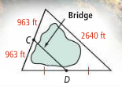

1. 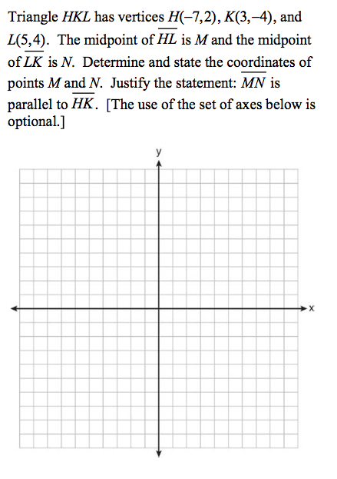 4.   
   